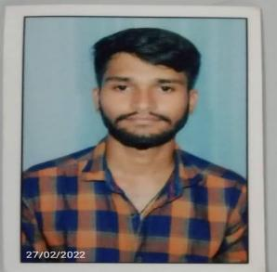**RESUME**

**Sandeepa M Mulakera**

**Email:sandeepam924@gmail.com**

**Mobile No: 9742121090**

# Career Objective

As a fresher. I want to use my creative skills and technologies that I am familiar with to implement

innovative thoughts that will benefit the organization in the long run and also help me in building my

professional career.

# Career Skills Summary:

**AWS:**

* Proficiency in **Cloud Computing** and **benefits of Cloud Computing.**
* Basic knowledge on Different **types of Cloud Computing deployment model.**
* Basic knowledge on **Different types of services, IaaS, PaaS, SaaS.**
* Basic knowledge on **Importance of scaling in cloud computing**

# Good Knowledge on IAM, EC2, AMI, EBS, OSC, Route53, VPC, ELB & AS, S3 & Glacier, Cloud Watch , SNS, RDS,

* Basic linux
* M S Office

# Professional Qualification

* Bachelor of Engineering, Tumkur- 2017to 2021 with 6.4 cgp
* PUC in MD collage sagar pass out 2017 with 58 .6 %
* SSLCin gov pu collage anvatti passout 2015 with 68.06%

**HOBBIES**

* Swimming
* Listening music
* Cooking
* Reading general blogs

# Personal Details:

* **Name :- S**andeepa m mulakera
* **Father’s Name :-**  Malakappa
* **Mother’s Name :-**  Kamlakshamma
* **Date of Birth :-** *14th augst 1999*
* ***Languages known :-*** *English, Kannada, hindi*
* ***Nationality :-*** *Indian*

# Declaration:

I Confirm that the information provided above by me is true to the best of my Knowledge and belief.

**Place: Shimoga** yours faithfully

# Sandeepa M Mulakera